Student Name:………………………………………

SPECIALIST MATHEMATICS UNITS 3 & 4

TRIAL EXAMINATION 1

2024

Reading Time: 15 minutes
Writing time: 1 hour

Instructions to students
This exam consists of 10 questions.
All questions should be answered in the spaces provided.
There is a total of 40 marks available.
The marks allocated to each of the questions are indicated throughout.
Students may not bring any notes or calculators into the exam.
Where more than one mark is allocated to a question, appropriate working must be shown.
An exact answer is required to a question unless otherwise specified.
Unless otherwise indicated, diagrams in this exam are not drawn to scale.
A formula sheet can be found at the end of this exam.

This paper has been prepared independently of the Victorian Curriculum and Assessment Authority to provide additional exam preparation for students. Although references have been reproduced with permission of the Victorian Curriculum and Assessment Authority the publication is in no way connected with or endorsed by the Victorian Curriculum and Assessment Authority.

© THE HEFFERNAN GROUP 2024
This Trial Exam is licensed on a non transferable basis to the purchasing school. It may be copied by the school which has purchased it. This license does not permit distribution or copying of this Trial Exam by any other party.

Question 1 (3 marks)

Evaluate .

Question 2 (3 marks)

Solve the equation for .

Question 3 (4 marks)

A soft serve ice cream machine automatically dispenses ice cream into a bowl, then dispenses chocolate topping into the same bowl. The volume of ice cream dispensed is normally distributed with a mean of 125 mL and a standard deviation of 4 mL. The volume of chocolate topping dispensed is normally distributed and has a mean of 20 mL and a standard deviation of 3 mL. The volume of chocolate topping dispensed is independent of the volume of ice cream dispensed.

a. What is the probability that a bowl of ice cream with chocolate topping has
a total volume more than 155 mL? Use , where Z is
the standard normal variable and give your answer correct to three decimal
places. 2 marks

b. If the cost of ice cream is $11 per litre and the cost of chocolate topping is
$15 per litre, what is the mean total cost, correct to the nearest cent, of a bowl of
ice cream with chocolate topping? 2 marks

Question 4 (3 marks)

Prove using mathematical induction that for all integers .

Question 5 (3 marks)

Let and , where .

The scalar resolute of in the direction of is .

a. Find the value of m. 1 mark

b. Find the vector resolute of that is perpendicular to . 2 marks

Question 6 (6 marks)

The part of the curve for is shown below.

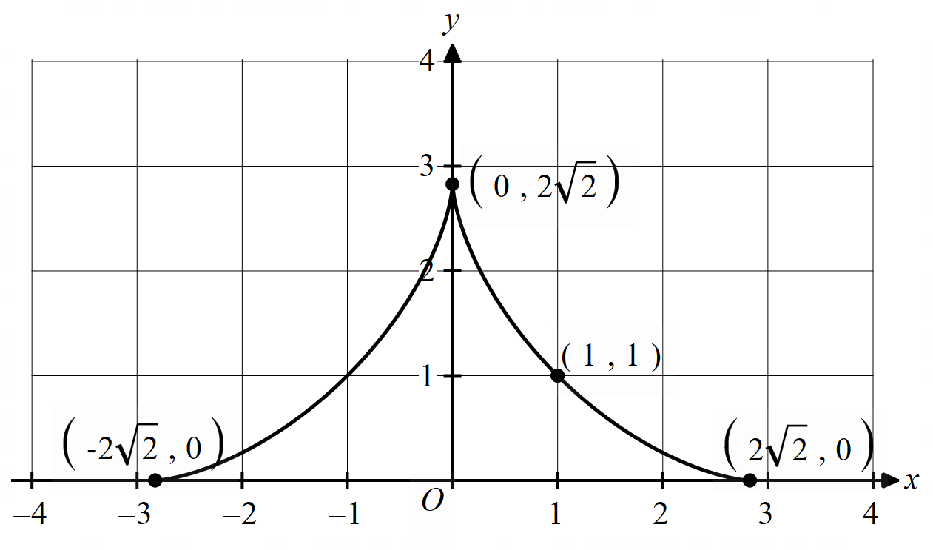

a. Find the gradient of the curve at the point (1, 1). 2 marks

The curve can also be described parametrically with the equations

for

b. Find the surface area obtained by rotating the curve shown about the x-axis. 4 marks

Question 7 (3 marks)

Solve for .

Question 8 (4 marks)

Solve the differential equation , given that .
Give your answer in the form .

Question 9 (4 marks)

The vector equations of two lines are as follows:

where .

a. If the angle between the two lines is , show that . 2 marks

b. Hence, find the Cartesian equation of the plane that contains the
lines and . 2 marks

Question 10 (7 marks)

Consider the function .

a. Show that has a stationary point of at . 2 marks

b. Show that has a point of inflection at . 2 marks

c. Sketch the graph of on the set of axes below. Label any asymptotes
with their equations and any axis intercepts and the stationary point with their
coordinates. There is no need to label the coordinates of the point of inflection. 3 marks

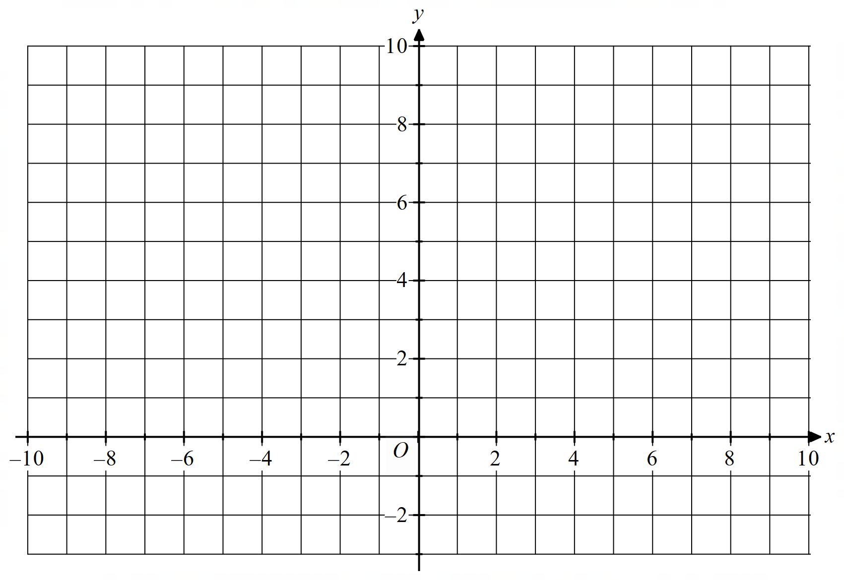

Specialist Mathematics formula sheet

Mensuration Data analysis, probability and statistics

area of a  circle segment |  | volume  of a sphere
volume of  a cylinder |  | area of  a triangle
volume of a cone |  | sine rule
volume  of a pyramid |  | cosine rule
for independent random variables
for independent identically distributed variables
approximate confidence interval for
distribution of  sample mean | mean
 | variance

Algebra, number and structure (complex numbers)

de Moivre’s theorem

Calculus Calculus – continued

product rule
quotient rule
chain rule
integration by parts
Euler’s method
arc length parametric
surface area Cartesian about x-axis

surface area Cartesian about y-axis

surface area parametric
about x-axis

surface area parametric
about y-axis

Kinematics Circular functions
acceleration
constant
acceleration
formulas

Vectors in two and three dimensions

vector scalar product

vector cross product
vector equation of a line
parametric equation
of a line
vector equation
of a plane
parametric equation
of a plane
Cartesian equation
of a plane

Mathematics Formula Sheets reproduced by permission; © VCAA. The VCAA
does not endorse or make any warranties regarding this study resource. Past
VCAA VCE® exams and related content can be accessed directly at
www.vcaa.vic.edu.au

End of formula sheet

